Sapsasa regionalised sport information and nomination for Western Metro
School Sport SA have identified the following sports to be part of the regionalised model. The regional teams will compete in the state carnival held in Adelaide (details below).
There are 10 regions across the state, each made up of multiple districts.
Girls Cricket – each region will enter 1 team of 11 girls.
Boys Netball - this is a new sport in 2024 with each region entering 2 teams of 10 boys.
Hockey - each region will enter 1 boys team (12 players), 1 girls team (12 players) and 1 mixed team (12 players – 6 boys / 6 girls).

Our region
Western Metro includes the following districts:
- Airport | - South West | - Western

Sport details
 | Boys Netball | Hockey | Girls Cricket
Trial details | Nominations are now open  Trial details will be sent to schools and nominated students at least 6 weeks prior to the event
State Carnival details | Dates: 24-26 June | Dates: 9-11 September | Dates: 4-6 November
 | Cost: $110 | Cost: $110 | Cost: $110
 | Team official:TBA | Team official: Renee Hanna | Team official: Daniel Murdoch
Trials are open to students in year 5 and 6 who wish to be considered for selection in the Sapsasa regional team to compete in the sport Sapsasa state carnival.
Trials are run in a safe and supportive learning environment with students involved in drills and competitive scenarios to select a team based on the following criteria:

- Ability and game sense in the sport
- Coachability (effort, teamwork, positive attitude, sportsmanship, listening and responding to feedback)

Transport: Parents/Caregivers are responsible for organising transport to and from the trials and for transport and accommodation if their child is selected in the regional team.
Requirements: Students must wear appropriate school sports top and footwear, bring sunscreen, sufficient food and drink along with any sport specific equipment (if they have it).
Supervision: Students will be under the supervision of the teacher team official and other identified responsible persons (with appropriate WWCC) to ensure supervision ratios are met.
Contingency plans: If unforeseen circumstances mean the trials are unable to go ahead, families and schools will be notified as soon as possible. Trials will either be rescheduled if time permits, or an alternate venue will be organised.

Nominations are now open
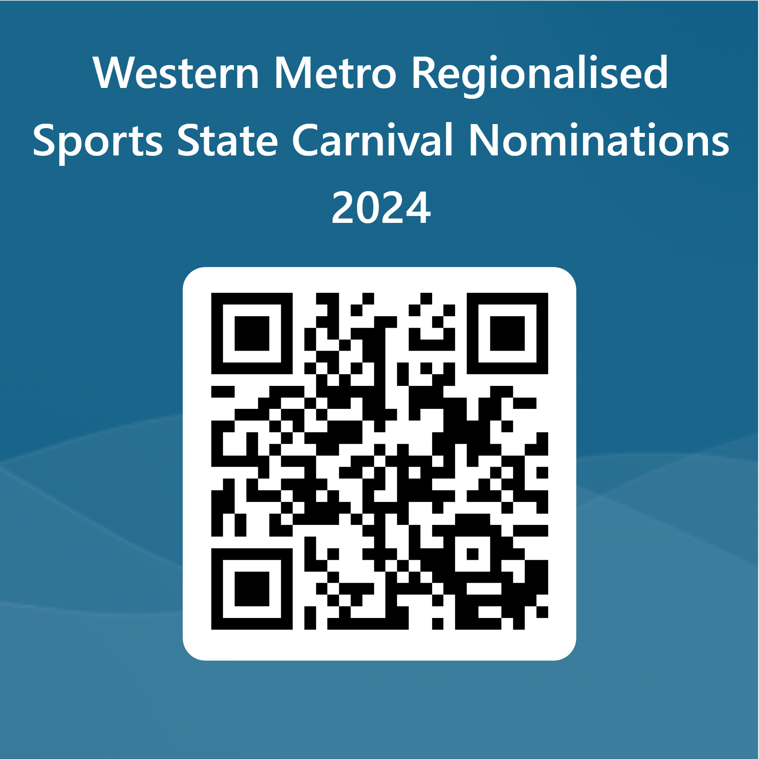
- Parents/Caregivers must nominate their child online ASAP.
- Students not nominated online before the trials will not be eligible to attend trials.
- To nominate, click https://forms.office.com/r/zMRtLYXL0q Or scan the QR code
- If you require support in completing the form please contact your school Sapsasa rep.
- Once you have submitted the form you will receive a confirmation email.
- The school will also receive a confirmation email of the nomination for their records
- Please note the school has the right to not approve a child’s involvement based on behaviour, attendance or other grounds as determined by the school.
- If you do not receive a confirmation email within 24 hours of completing the form, contact the convenor.

Further information
Once a team has been selected, further details regarding the carnival and trainings will be provided.
For more information, please ask your school Sapsasa representative or contact the convenor.
Name: | Email: | Mobile:

