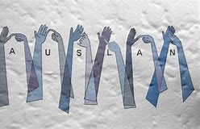

Would you like to learn or improve your Auslan skills?

Classes resumes in Term 3, newcomers welcome!

Classes start on Friday, Week 1 in Rm 2.1!
Brighton Primary School will be hosting Auslan lessons for parents, families and friends on Friday mornings. Our experienced BSSO team will be organising and running these fun and informative classes recommencing in Term 3. The Parent Workshop will cover fingerspelling, basic communication and a variety of topics to improve your Auslan skills and vocabulary. Bring a smile, notebook and a pen.
Where: Learning Area 2 – Room 2.1
Time: 9.00 am to 10.00 am (Fridays)
Frequency: Weekly
Cost: Gold coin donation
Are you interested? Do you have any questions? Please send an email to Catharine to register your interest: catharine.carlin699@schools.sa.edu.au

