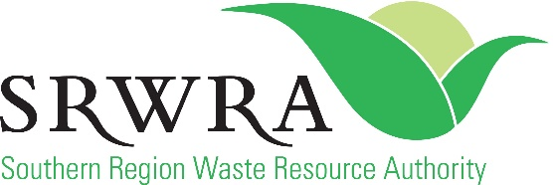

SRWRA School Recycled Art Competition 2021 – REGISTRATION FORM
Registering for the SRWRA School Recycled Art Competition 2021 enrols you into a community awareness program to raise awareness about ‘recycling and repurposing’ resources and opportunities in South Australia.

School name: …………………………………………………………………
School address: …………………………………………………………………
School email: …………………………………………………………………
School phone number: …………………………………………………………………
Number of participants: …………………………………………………………………
Year level/s of participants: …………………………………………………………………
Primary contact name: …………………………………………………………………
Primary contact email: …………………………………………………………………
Primary contact phone number: …………………………………………………………………
Secondary contact name: …………………………………………………………………
Secondary contact email: …………………………………………………………………
Secondary contact phone number: …………………………………………………………………
Please detail your planned idea for your SRWRA School Recycled Art Competition entry:
………………………………………………………………………………………………………………………………………………………………………………………………………………………………………………………………………………………………………………………………………………………………………………………………………………………………
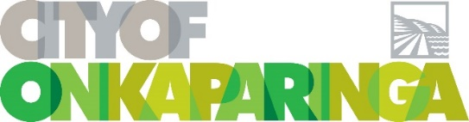
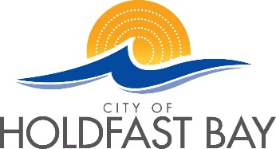
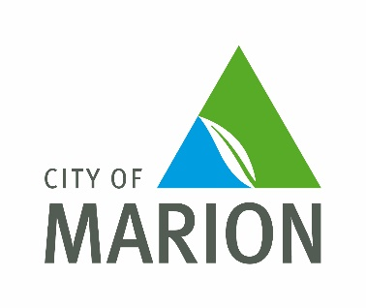
Date:…………… Name…………………………………………………………………
Signature…………………………………………………………………

