Performing Arts

Hello, my name is Mel Phillips. I am one of the Arts Educators at Brighton Primary School. This is my second year at Brighton and I am thrilled to be back. You will find me in the Art room from Monday to Thursday and Steph Dawson in the space on Thursday mornings and Friday. I have been teaching for 14 years in numerous roles including, Well-being Coordinator, Science/I.T teacher, classroom teacher R-7 and specialist Arts teacher. We are both practicing artists – My main influence is from my Grandmother, an artist for 60 years and Steph from her father who has been painting with her since she was able to hold a brush.
In the Art room, our lessons focus on visual arts and drama. Singing and dancing are also incorporated at times especially with the junior primary classes. This year the first semester – term 1 & 2 will focus on Performing Arts and semester 2 – term 3 & 4 will focus on Visual Arts.

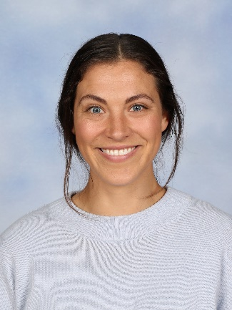
Students in Drama will explore and express ideas and narrative structures through role play, improvisations, and scripted performances. Students will use scripts and real or imagined events to develop and create characters and situations by using their voices, facial expressions, bodies, movement and language.

Learning in Visual Arts involves experimenting with conventions and techniques, exploring ideas, practices and artworks from different cultures and times, particularly those of Aboriginal and Torres Strait Islander Artists. By focusing on different artists and art forms, students will represent a theme, concept or idea, different views, beliefs and opinions, and use artists as inspiration for their own representations.

We are constantly trying to stretch students’ learning through an Art lens by complimenting and extending what is happening in their home classes. This may be in the form of showing understanding and interpretation through mime, storytelling, dance or a sculpture, print, painting or drawing. For example, aligning historical topics with relevant artist studies, creating meaningful performances out of certain social studies themes.
We are so fortunate to be in Adelaide, as the Arts is still happening around us especially at this time of year. Term 1 is a fantastic time to be exploring Adelaide with the Fringe and Adelaide Festival still going ahead and right at our doorstep.
- The FRINGE https://adelaidefringe.com.au/ runs from February 19th until March 21st and has about 50 shows specifically targeted at children. Many are free including buskers and workshops in the Garden of Unearthly Delights. Some of our very own Brighton Primary students are in the Fringe this year so look out for them. https://adelaidefringe.com.au/fringetix?genre%5B%5D=children&view=Events

- The ADELAIDE FESTIVAL is on from February 26th until March 14th https://www.adelaidefestival.com.au/whats-on/ https://www.adelaidefestival.com.au/media/7073/af21-guide-plus-planner.pdf and has many programs/sessions for children including writer’s week running from February 27th until March 4th.

Art and Drama skills and knowledge are taught to enhance the abilities and creativeness of all children and encourage them to have a positive life long relationship with the Arts. We also focus on ways to build confidence, imagination, and communication skills in our arts space.

The Art Room Studio is located upstairs in Learning Area 2, Room 12. We have an open door policy and everyone is welcome. I would love to hear from any of the community who have skills in the ARTS who would like to share them with us. Please come and have a chat or I can be contacted via email at mel.phillips456@schools.sa.edu.au and Steph can be contacted at stephanie.dawson689@schools.sa.edu.au.

On Acquaintance Night Steph and I will be in our room from 5.35-6-00pm. Please feel free to visit us.
Mel Phillips & Steph Dawson

