Health and Physical Education
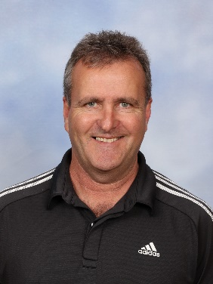
My name is Jeff Miller and I have been the PE teacher at Bri ghton for the past 7 years. Prior to this, I have taught Early Years, Middle Years, Indonesian Language and PE. Brighton Primary provides many opportunities for students to participate in SAPSASA/Sport Carnivals. These include Beach Volleyball, Indoor Volleyball, Soccer, Football, Basketball, Netball, Rugby, Lacrosse, Tag Rugby, Viva 7’s Rugby, Tackle Rugby, Cross Country and Athletics. Students born in 2011, 2010, 2009 and 2008 may also trial for South West District teams throughout the year. In term 1 we have Beach Volleyball, Viva 7s Touch Rugby, Lacrosse and Swimming/Football/Netball District trials.

This year I will be teaching 17 classes. 8 of these classes will have Health and Physical Education lessons, 8 will only have Physical Education lessons, 1 will have only a Health lesson. I have one Foundation class, year 2/3s, 4s, 5s, 6s and 7s.

Objectives:
- Lessons are based on knowledge that there are different levels of ability with fundamental movement skills from class to class and year level to year level.
- Providing opportunities for students to participate in a range of skill- based activities.
- Lessons are based on 1. Coordination & Agility activities, 2. Movement challenges and games
- Creating opportunities for students to work with a partner, in small groups, modified teams and as a whole class

Foundation to year 4 students perform movement sequences with consistency and control and demonstrate cooperation, effort and practice in physical activity. Students demonstrate proficiency in the fundamental movement skills of static balance, sprint run, vertical jump, catch, hop, side gallop, skip and overarm throw through practice and application in different games and sports.
Year 5, 6 and 7 students understand the elements of movement and compose and perform movement sequences with control and coordination in various contexts. Students demonstrate teamwork, tactics and strategies when participating in team games. They demonstrate proficiency in the fundamental movement skills of leap, kick, two- handed strike and dodge and apply them in a range of challenging physical activity contexts. Students participate in a range of moderate to vigorous physical activities and apply movement skills with increased confidence and precision.
Lessons include modified sports, strategy games and specialised sport activities. Examples of strategy games include: Capture the flag, Gates, Raiders, Buroinjin, Risk it Cricket etc. Examples of modified games include: Tag Rugby, Modified Netball, AFL 9s, and Speedball etc. Examples of specialised sports include: Lacrosse, Korfball, Athletics, Rugby, Orienteering etc.

Health lessons will be based on developing knowledge, understanding and skills for students to lead healthy, safe and active lives. The content enables students to explore their own sense of self and the factors that contribute to and influence their identities. Students learn about emotions, how to enhance their interactions with others, and the physical and social changes they go through as they grow older. Part of the Child Protection Curriculum will be taught by myself and the rest of the Health curriculum will be covered by class teachers.

Jeff Miller - Jeff.Miller740@schools.sa.edu.au

