Health and Physical Education
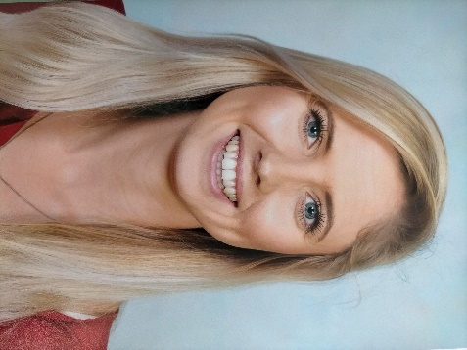
My name is Amy Hughes and this will be my first year teaching at Brighton Primary School. I have previously worked as a classroom and specialist teacher across all school year levels, and have coached and managed specialist sporting teams including volleyball.
I will be working with other specialists to deliver the Health and Physical Education curriculum across the school this year. We will guide and encourage students to take positive actions to protect, enhance and advocate for their own and others’ health, wellbeing, safety and physical activity participation. Students will have movement-based learning experiences and may understand and appreciate their significance to personal, social, cultural, environmental and health practices and outcomes.
Please see below for some of health and PE focuses for the term:
Reception students will: Identify actions to keep themselves healthy, safe and active. Perform fundamental movement skills and solve movement challenges. Demonstrate how to move and play safely.
Years 1 – 3 will: Explore and select strategies to be healthy, safe and active at school. Demonstrate fundamental movement skills in a variety of movement sequences and situations. Apply safe play strategies to different activities and will make connections between outdoors and their health.
Years 4-5 will: Interpret health messages and understand the benefits of being healthy and physically active. Apply strategies to work cooperatively and apply rules fairly. Discuss the influences on safe and healthy choices. Create and perform movement sequences using fundamental movement skills and the elements of movement.
Years 6-7 will: Describe their own and others’ contributions to health, physical activity, safety and wellbeing. Demonstrate fair play and skills to work collaboratively. Access and interpret health information and apply decision making and problem solving skills to enhance their own and others’ health, safety and wellbeing. Apply the elements of movement when composing and performing movement sequences.
I look forward to working with the students of Brighton Primary School!
Amy Hughes - amylouise.hughes229@schools.sa.edu.au

