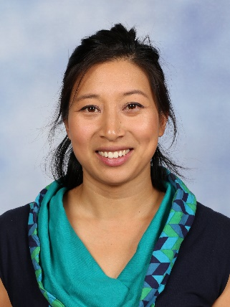
Music
Hello, my name is Amanda Cheah and this will be my fourth Year at Brighton Primary School teaching Music. I have a Bachelor of Music (performance jazz voice) and taught voice privately, studied psychology and Spanish before obtaining my teaching masters. I continue to play ukulele in a local ensemble for fun and will continue learning cello this Year.

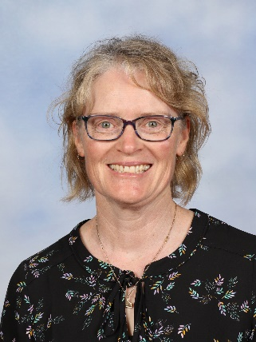
Elizabeth McDonald will be teaching Foundation classes 3.2, 3.3 and 3.4, 1.3 and 4.2 classes on Wednesdays out of the STEM room. She is a very talented musician and teacher based at Reynella Primary School for the rest of the week. She has a background in piano accompaniment and private tuition and has a lot of experience with brass bands.

This term ‘Just Add Music (JAM)’ will visit in week 7 March 12^{th.} They have been very kind and rescheduled us twice since their show for us in 2020 was cancelled. There will be two identical shows, one in the morning and one in the afternoon, so the students can get a better view and participate more in our hall.
Year 3 students will not attend JAM as I have booked us in to participate in the opening ceremony of DreamBig festival this Year. We will also watch, ‘Wolfgang’s Magic Musical Circus.’ More details about that to come in term 2.
Curriculum Overview
Foundation and Year 1 students will be focusing on the elements of music this term. They will be looking at the JAM songs leading up to our concert on March 12th.
Year 2, 3, 4 and 5 students will be focusing on beat this term and will begin a unit of work called, ‘The Power of Yet’ adapted from work by Kristie Fudge. This unit is themed around Growth Mindset and the song is all about growth mindsets. We will work on playing different parts of the piece on different instruments, arranging and performing them in a group for the main assessment.
Years 6 and 7 students will also be focusing on beat this term and will begin a unit of work called, ‘Doin’ It Right’ adapted from a unit written by Kirrabelle Lovell. There are tricky parts to play and sing on a range of instruments both tuned and untuned. We will learn different parts of the piece on different instruments and arrange and perform them in a group for the main assessment.

The Primary Schools Music Festival held at The Adelaide Festival Theatre will go ahead this Year from Wednesday 8th - Saturday 18th September 2021, weeks 8 and 9 of term 3. Festival of Music/Senior Choir will be open to committed students in Years 5, 6 and 7. Priority is given to Year 7 and Year 6 students in the first instance. Priority Rehearsals will be held in the music room on Thursday afternoons. We will commence in week 3 planning an admin meeting about our first excursion in week 4. We have our first cluster rehearsal at Paringa Park on the 18th of February, Thursday week 4.

Junior Choir will run again this semester during Tuesday lunchtime for students in Years 3 and 4. This is voluntary for both students and myself as it is during our lunch time. Consistent committed members will be invited to perform at Holdfast Mini Fest, held at Paringa Park Primary early in Term 3.

Ukulele club will commence later in the term to allow Year 3-7 students who wish to practice their pieces from class. If they chose to come with a group of friends with an idea of what they would like to play, I will try and support them as best I can. Again, this is during our break time and not a lesson as such and both the students who attend and I are there on a voluntary basis.

All foundation, Year 1 and Year 2 students will participate in JP singing on a rotating roster on Friday afternoons in the STEM room. Typically, this is a couple of sessions a term.
Feel free to pay the music room a visit between 5.35 and 6.00 on Acquaintance night. I would love to see you.

Amanda Cheah - Amanda.Cheah706@schools.sa.edu.au

