English as an Additional Language or Dialect 2021
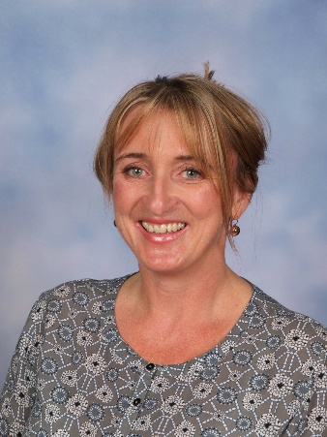
Hello, my name is Charlotte Archbold and I provide learning support and assist children who have English as an Additional Language or Dialect (EAL/D). Teaching and learning programs are delivered in whole class sessions, small groups and individually.

I have worked as an educator in learning support for many years. I have a Master’s degree in Studies of Asia and have spent time teaching in the UK, across Australia, and in Indonesia. In addition to teaching I enjoy creative writing and have two young adult novels published and a third book out next year.

You can find me opposite the music room in Learning Area 2. I am in school Monday, Tuesday and Wednesday.

Term 1 Overview
Harmony Week 15th-21st March 2021
Harmony week will be promoted in EAL/D sessions. Harmony Week celebrates Australia’s cultural diversity through inclusiveness, respect and a sense of belonging for everyone.

Curriculum Overview

Foundation children will be scaffolded in small group sessions with a focus on oral language. We will be exploring language associated with school, prepositional phrases and attributes. Children will communicate to express their ideas on familiar topics using visual aids, modelled text and/or teacher support. Children will create simple first-person recounts and descriptions to make simple story books.

In Year 1 and 2 children will continue with an oral language focus alongside the written grammatical development of language skills. Using personal experience, they will create first person recounts including the linear sequencing of events through the use of simple sentences, conjunctions, and punctuation. Using book making skills they will create narratives based on Harmony Week themes.

In Year 3 and 4 children will analyse a range of narrative texts and personal stories using a variety of comprehension strategies. They will focus on developing grammatical skill sets to create increasingly complex narratives; including speech, description, imagery and an awareness of characterisation.
Year 5 and 6 children will explore strategies for planning and refining work such as editing for consistent use of grammar, punctuation, and spelling. Control of direct and indirect speech and control of verb/ noun groups and tenses. Children will write a narrative using story prompts which reflect concepts of community and society and how they are represented by language.
Year 7 children will be supported in class or in study groups with assignments, homework and the learning focus of the Year 7 community.

Feel free to come and talk to me between 5.35 and 6.00 on Acquaintance Night.

Charlotte Archbold - charlotte.archbold233@schools.sa.edu.au

