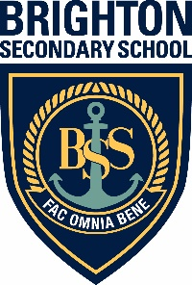

Brighton Special Interest Music
Information Evening for Years 6 & 7

Everything you need to know about auditioning for the
Brighton’s Special Interest Music Program

Tuesday 30 March 2021, 5.30 to 6.30pm
Brighton Secondary School Concert Hall
Followed by a free short concert on the front oval
(bring a picnic dinner and chairs)

For all enquiries please call Pam Parsons 8375 8215
email: pamela.parsons939@schools.sa.edu.au

