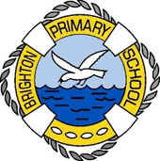

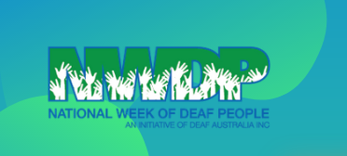

Let’s celebrate National Week of Deaf People together at Brighton Primary School – Week 10

Come and join our “Silent (Auslan only)” Breakfast

Tuesday morning at 8.15am in the hall

We are having a very special breakfast in Week 10 to help us celebrate National Week of Deaf People within our community. We will have toast, fruit and hot chocolate available to all students. Come and join us for breakfast, while using and practicing your Auslan skills.

We are asking for a Gold Coin donations that will go towards at Deaf charity/fundraiser.

Come along and join our fun and delicious event!