Monday 16th December  Brighton Primary School OSHC Vacation Care Program December 2019 / January 202 Phone: 8377 2655 Mobile: 0488 238 223 | Tuesday 17th December | Wednesday 18th December | Thursday 19st December | Friday 20th December
Wheelies Day  Bring your favourite pair of wheels to OSHC (and helmet & pads) and come enjoy a day of pedalling and scooting around @ school. Race around our track and see who is the fastest! We will be doing Hama Beads craft, watching racing movies, cooking and preparing our tacos for lunch.  Supplied Lunch  Make your own Tacos | Animal Day  Group 1 (Years R-2)  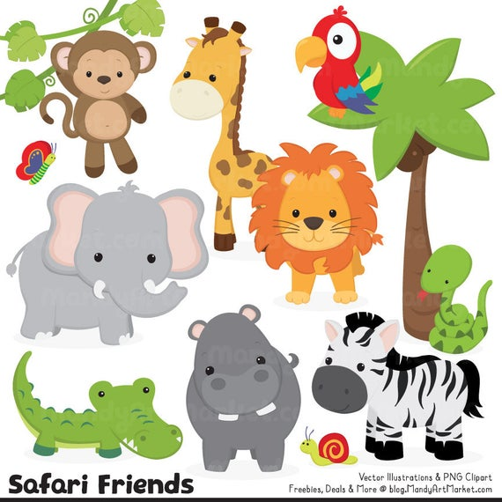  Come dressed as your favourite animal! Animals Anonymous will be visiting from 10:30am, with a range of reptiles and marsupials.  We will be doing animal themed cookies, animal face paint and craft activities.  Museum & Botanical Gardens Lunch  Group 2 (Years 3-7)  Catch the train to the city & explore the South Australia Museum for a scavenger hunt, followed by a visit to the Botanic Gardens for lunch.  Transport  Public Train  Depart: 9:30 am  Return: 3:00 pm | Plaster Fun House  Group 1 (Years R-2)  Come paint and express your creativity as we visit Plaster Fun House!  Transport  Walking  Depart: 10:00am  Return: 12:00pm  Crazy Craft Day  Group 2 (Years 3-7)  We will be using our imagination and making our own air dried clay. Come create, manipulate and paint creations! | Marion Outdoor Swimming Centre  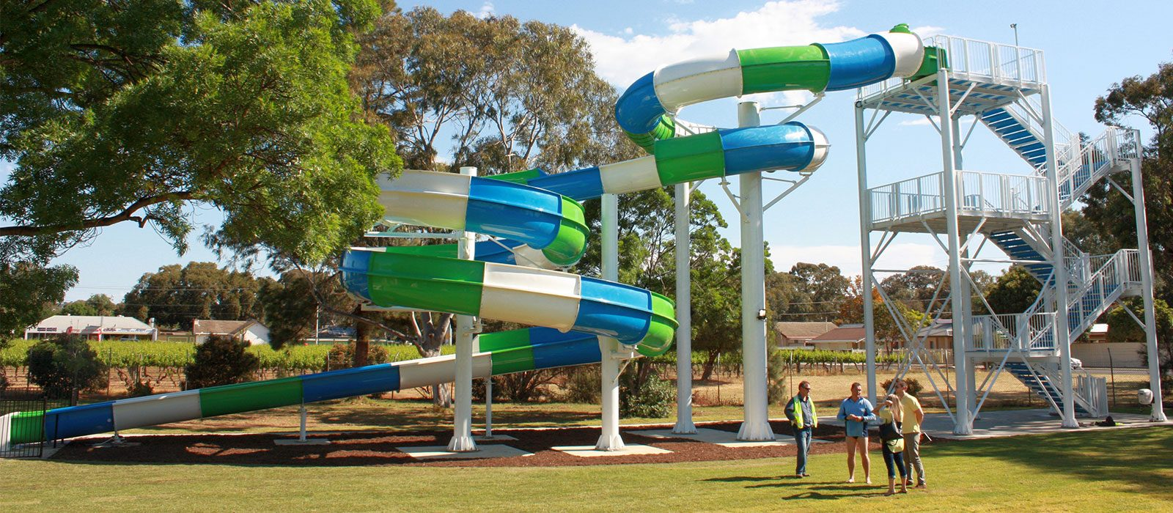  Today we will be visiting the Marion Pool for swimming, lots of fun and most of all slides! We will be traveling in two groups (R-2 & 3-7).  Transport  Private Bus  Group 1 (Years R-2)  Depart: 9:30 am  Return 1:00 pm  Group 2 (Years 3-7)  Depart: 12:00 pm  Return: 3:00 pm  Please bring a towel & change of clothes | Christmas @ OSHC  Today we will be visiting Fasta Pasta for a “OSHC Family Lunch” – and we will being having a visit from Santa Clause!  Come enjoy Christmas themed craft and activities as we prepare for the festivities!  Depart 12:00 pm  Return 1:30 pm  Supplied Lunch  Fasta Pasta
Monday 6th January | Tuesday 7th January | Wednesday 8th January | Thursday 9th January | Friday 10th January
Karate Day  Come enjoy a day of karate themed activities! We are having the Academy of Self Defense and Martial Arts come in and teach a Kids Safe Self Defense & STOP BULLIES session. The session will be children friendly and help students develop skills to overcome bullies and look after their own wellbeing.  We will also be making our own karate belts and headbands, watching karate kid, and cooking.  Session  1:00pm to 2:00pm | Games Bonanza  Group 1 (Years R-2)  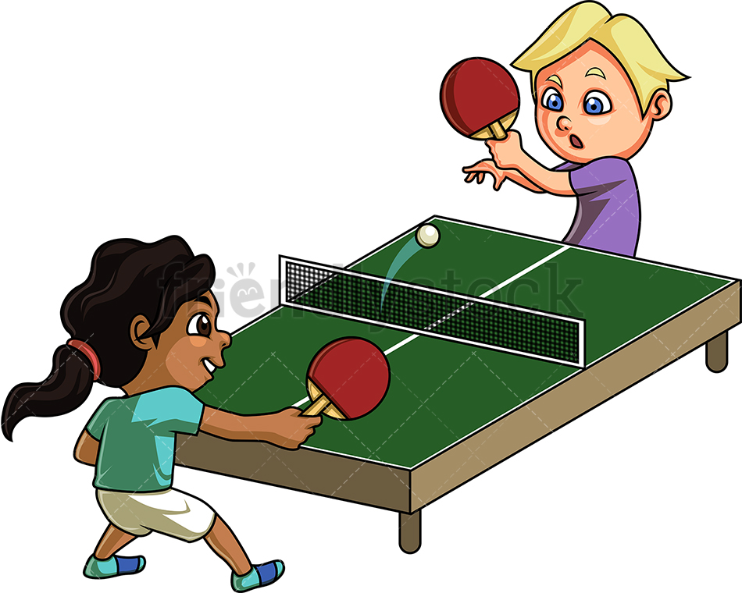  Come enjoy a day filled with Daytona Twin Racers, giant board games, foosball & table tennis tables. Who will conquer the race track and become a Daytona legend?  Roller Skating & Swimming @ Noarlunga Leisure  Group 2 (Years 3-7)  Catch the train to Noarlunga where we will lace up our skates and “get rolling for 2 hours.” After we are done skating, kit up for a swim in the pool!  Transport - Public Train  Depart 09:00 am  Return 03:30 pm  Please bring a towel & change of clothes | Nature Play Day @ East Adelaide School  Today we will visiting Ben’s friends at East Adelaide School for a day of nature play, a barebecue & making new friends! Nature play will include water play & potion making, “Inventor’s Playground”, plus waterslides.  Supplied Lunch  Sausage Sizzle  Transport - Private Bus  Depart 9:30am  Return 2:30pm  Please bring a change of clothes and suitable nature play footwear. | Bowland  Group 1 (Years R-2)  Come join us and catch the train to Westfield Marion and enjoy 2 games of bowling! Who will score the most strikes?  Transport - Public Train  Depart 10:00am  Return 1:00pm  Games Bonanza  Group 2 (Years 3-7)  Come enjoy a day filled with Daytona Twin Racers, giant board games, foosball & table tennis tables. Who will conquer the race track and become a Daytona legend? | Disco DJ Day  Come party at OSHC and enjoy a Disco day, where we will be holding a party in the hall with absolute bangers! Kids will be able to sing, dance and party for 1 and a half hours as Bop til you Drop visit us. We will be doing disco craft, putting together a DJ playlist for the party and playing dancing games.  Come dressed in your best 70s disco gear!  Supplied Lunch  Hamburgers
Monday 13th January | Tuesday 14th January | Wednesday 15th January | Thursday 16th January | Friday 17th January
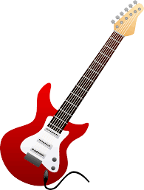  Rockstar Day  ROCKSTAR  DAY  Today we will be visited by “Jam Band.” Children will enjoy an interactive rock performance where the children will be invited to join in.There will also be fun and games after the performance.  Jam Band will be visiting from 1pm.  Children will also be able to do rockstar themed craft, watch School of Rock, play Just Dance & compete in an air guitar contest!  Come dressed in your best rockstar gear! | Brighton Beach Playground  Group 1(Years R-2)  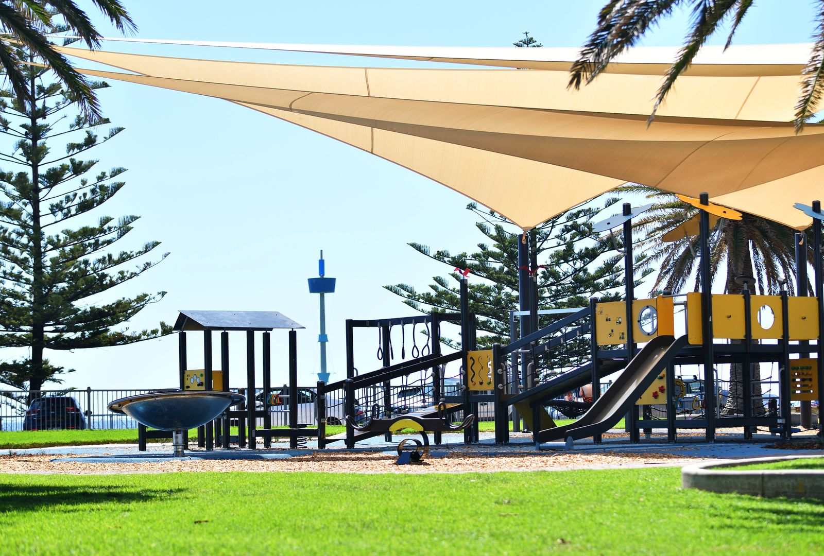  Walk to Bindarra Reserve @ Brighton. Enjoy a visit to the playground & walk down the jetty, followed by some fresh hot chips.  Transport - Walking  Depart 11:00am  Return 1:30pm  Event Cinemas Marion  Group 2 (Years 3-7)  Come see “Jumani: The Next Level” at Event Cinemas Marion. Bring up to $10 spending money.  Transport – Public Train  Depart 9:30am  Return 1:30pm | Event Cinemas Marion  Group 1 (Years R-2)  Come see “Frozen 2” at Westfield Marion. Bring up to $10 spending money.  Transport – Public Train  Depart 9:30am  Return 1:30pm  Brighton Beach Playground  Group 2 (Years 3-7)  Walk to Bindarra Reserve @ Brighton. Enjoy a visit to the playground & walk down the jetty, followed by some fresh hot chips.  Transport - Walking  Depart 11:00am  Return 1:30pm | Bounce  Come bounce your socks off with us as we visit Bounce. Enjoy two hours of endless free jumping, dodgeball, slam dunks and shooting hoops.  Transport - Private Bus  Depart 10:00am  Return 2:00pm | Wet & Wild @ OSHC  Come enjoy a day filled with water play at OSHC. Come cool off and ejoy our very own waterslide for the day, whilst also hosting a water fight.  We will be walking to Juniper and Pine in small groups where we will get to cook our very own wood oven pizza!  Supplied Lunch  Make your own pizzas  Please bring a towel, change of clothes and suitable footwear (no thongs).
Monday 20th January | Tuesday 21st January | Wednesday 22nd January | Thursday 23rd January | Friday 24th January
Ninja Warrior Day  Come enjoy a fan favourite Nina Warrior Day – back by popular demand! We will be hosting our own Ninja Warrior Course, making ninja headbands, making sushi for afternoon snack & having a Super Smash Bro’s tournament.  Come dressed in your best ninja costume! | Imagination Kidz Play Cafe  Group 1 (Years R-2)  Come enjoy a 2 hour session at Imagination Kidz! Come jump, slide, bounce, climb and crawl on their awesome indoor playground!  Transport  Private Bus  Depart 10:00am  Return 1:30pm  Group 2 (Years 3-7)  Mini Golf @ OSHC  Come tee off @ OSHC and enjoy a day of putt putt. We will be holding a tournament on our very own course. Who will score a hole-in-one?  Come dressed up like a golfer! | Marion Outdoor Swimming Centre  Today we will be visiting the Marion Pool for swimming, lots of fun and most of all slides! We will be traveling in two groups (R-2 & 3-7).  Transport  Private Bus  Group 1 (Years R-2)  Depart: 9:30 am  Return: 1:00 pm  Group 2 (Years 3-7)  Depart: 12:00 pm  Return: 3:00 pm  Please bring a towel & change of clothes | Fairy Robot Pirate Day  Group 1 (Years R-2)  Come express your creativity at our very first Fairy Robot Pirate day! Create your own costume and live in a fantasy for the day, followed by a dance battle. We will be doing dress up making, fairy, robot & pirate craft, and cooking lunch.  Supplied Lunch  Pizza Hut Lunch & Shop @ Marion  Group 2 (Years 3-7)  Catch the train to Pizza Hut for a buffet lunch, followed by a visit to Westfield Marion. Bring up to $10 spending money.  Supplied Lunch  Pizza Hut  Transport  Public Train  Depart: 11:30 am  Return: 3:30 pm | Movie & Electronics Day  Bring your favourite electronic device and enjoy a day in at OSHC playing games & watching movies.  Come enjoy our last day of the summer holidays.  We will have school iPads available to use on the day.  Devices must not have cellular on them and photos are not permitted to be taken on your devices whilst at OSHC.  Supplied Lunch  Party Food

OSHC WILL BE CLOSED FROM 6PM FRIDAY 20th DECEMBER UNTIL 7AM MONDAY 6th JANUARY.
ENJOY YOUR CHRISTMAS BREAK

Please ensure your children have suitable footwear (no thongs) and clothing for all excursions and activities.
It is policy that children bring a drink bottle every day they attend OSHC.
On water based days, children need to bring a towel and a change of clothes.
Sunsmart hats are a requirement, children who wear caps to OSHC will need to wear a sunsmart hat when outside.
Please note – if the weather is scheduled to be over 36 degrees on an excursion day, unfortunately the excursion will be cancelled.
*Risk Assessments have been completed for all excursions and incursions and are available for viewing.

