Monday 30th of September | Tuesday 1st of October | Wednesday 2nd of October | Thursday 3rd of October | Friday the 5th of October
BRIGHTON OSHC MINI OLYMPICS  Today we will be hosting the Brighton OSHC Mini Olympics.  Join us for a fun active day at OSHC!  We have hired a smoothie bike for the day and see who will hold the record for the fastest smoothie.  Activities will include:  Long jump, relays, running races, three-legged race, paper plane competition, create your own medal and cooking stir fry for lunch.  LUNCH PROVIDED  Chicken or Veg stir fry  Children will need to bring sun smart clothing, walking shoes, water bottle and recess.  In-house  Child Staff Ratio: 15:1 | BRIGHTON NINJA WARRIOR  We have hired an inflatable obstacle course and will be hosting our very own Ninja Warrior time trial. Come dressed in your best costume and see what time you will set.  Activities will include:  Ninja Warrior time trial, origami, Ninja headband, cooking sushi for snack, Pokemon craft and a Japanese film.  Children will need to bring sun smart clothing, walking shoes, water bottle, recess and lunch.  In-house  Child Staff Ratio: 15:1 | BELAIR NATIONAL PARK  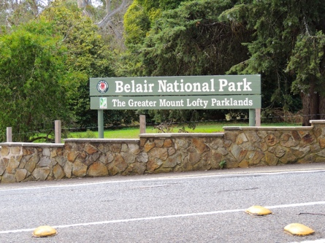  Join us as we explore Belair National Park!  We will be visiting the adventure playground, exploring on a bush walk, group games, and enjoying a sasuage sizzle for lunch.  LUNCH PROVIDED SASUAGE SIZZLE  Children will need to bring sun smart clothing, walking shoes, water bottle and recess.  Excursion  Depart: 9:30am  Return: 3:00pm  Transport: Private Bus  Child Staff Ratio: 8:1 | ADELAIDE ZOO  Brighton OSHC will be visiting the Adelaide Zoo. How many animals will you see?  Activities will include:  Visiting the zoo, animal paper plate craft, hama beads, watching Madagascar  Children will need to bring sun smart clothing, walking shoes, water bottle and recess and lunch.  Excursion  Depart: 9:30am  Return: 3:00pm  Transport: Private Bus  Child Staff Ratio: 8:1 | Marion BowLand  Today we will be catching the train to Marion Bowland and you will get to play two games of ten pin bowling.  Activities will include:  Ten pin bowling, circus games, making playdough, cooking pinwheels for snack, games outside, print outs  Excursion  Depart: 10:15 am  Return: 1:30pm  Transport: Public Train (Seaford line)  Child Staff Ratio: 8:1  Children will need to bring sun smart clothing, walking shoes, water bottle, recess and lunch.
Brighton Primary School OSHC Vacation Care Program October 2019 Phone: 8377 2655 Mobile: 0488 238 223

Brighton Primary School OSHC Vacation Care Program October 2019 Phone: 8377 2655 Mobile: 0488 238 223

Monday 7th of October | Tuesday 8th of October | Wednesday 9th of October | Thursday 10th of October | Friday the 11th of October
PUBLIC HOLIDAY CENTRE CLOSED LABOUR DAY | FASTA PASTA  Group 1 (Rec to Year 2)  Today we will be walking to Fasta Pasta for lunch. You will enjoy a Kids Meal Deal which will include your choice of pasta, juice and gelati.  Excursion  Depart: 12:30pm  Return: 1:30pm  Transport: Walking  Child Staff Ratio: 8:1  Intencity  Group 2(Year 3 to 7)  Today we will be walking to Westfield Marion to Intencity for an hour and a half lock in who get the ultimate score.  Excursion  Depart: 10:00am  Return: 1:15pm  Transport: Walking  Child Staff Ratio: 8:1  No Spending money | Dinosaur Day  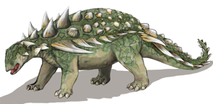  Today we will be visited by E.G Excursions as they present to us LIFE LONG AGO INCURSION. You will get to be a real life palaeontologist and discover your own fossils.  LUNCH PROVIDED  Activities will include:  Cooking biscuit bones, craft,  dinosaur movie, playing outside, games in hall  In-house  Child Staff Ratio: 15:1  Children will need to bring sun smart clothing, water bottle and recess. | Capri Theatre  Today we will be heading to the Goodwood Capri Thearte for the showing of Abominable.  Activities will include:  Make and play with our own snow, snowmen craft, playing outside, games in hall  Excursion  Depart: 10.00am  Return: 2.15pm  Transport: Private Bus  Child Staff Ratio: 8:1  Spending money $5  (Please hand to staff on arrival in labeled bag)  Children will need to bring sun smart clothing, water bottle and recess and lunch. | The Great Brighton oshc op shop scavenger hunt  Today we will be visiting the local Op Shops on Brighton Road and joining in on a Scavenger Hunt. Whilst partaking in the hunt we will be shopping for Brighton OSHC’s dress-up box.  Will you be on the winning team?  Activities will include:  Scavenger hunt, god’s eye craft, print outs, handball tournament, nature play, games in hall, print outs  Excursion  Depart: 10:30am  Return: 12:30pm  Transport: Walking  Child Staff Ratio: 8:1  Children will need to bring Sun smart clothing, water bottle and recess and lunch.

